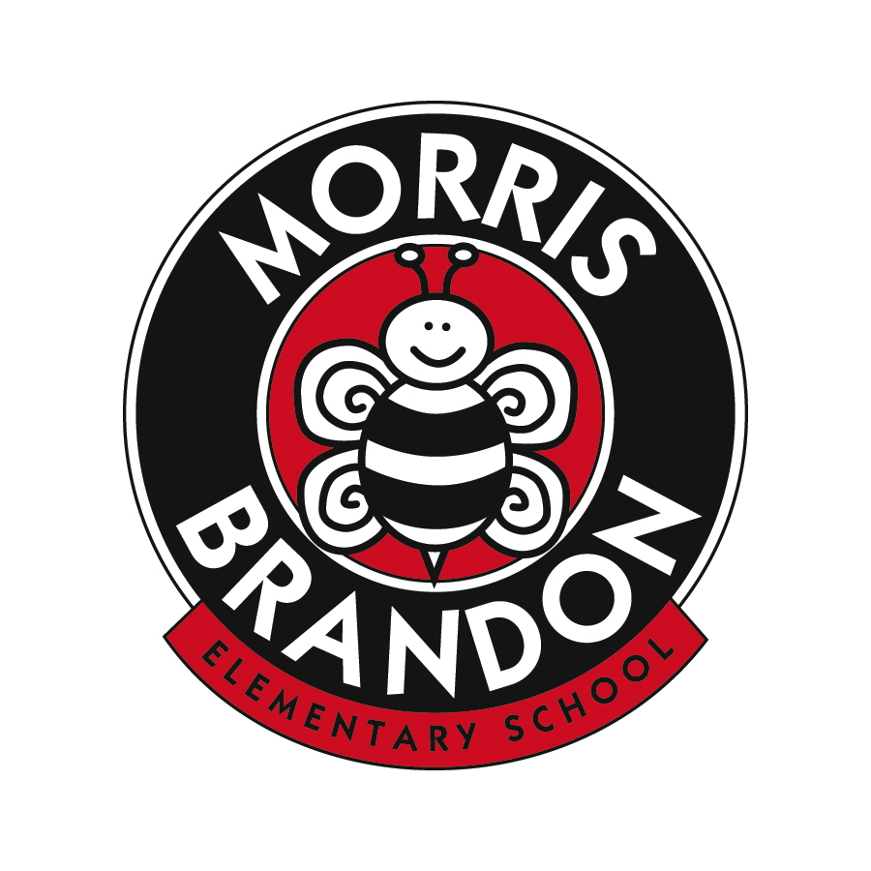
Morris Brandon Elementary School Foundation, Inc.
Request for Funding
2016-17

Proposal Title:

Teacher/Grade/Department Submitting:

Email Address/Contact #:

Date of Request:

Item Requested:

Amount Requested:

Description of Request:

How does this purchase support the approved MBESF’s mission to support the educational initiatives and programs at Brandon?

Number of students who will use/be impacted:

Have all other opportunities to obtain funding through APS been researched and exhausted?

Please feel free to add additional support as needed.

