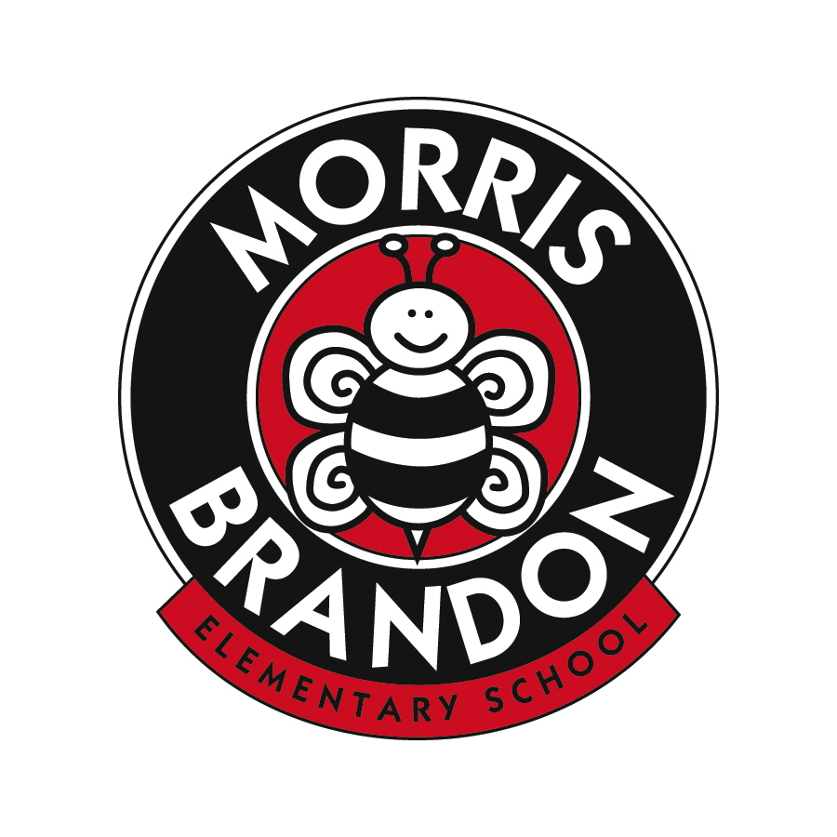
Morris Brandon Elementary School Foundation, Inc.
Request for Funding
2020-2021

Proposal Title:

Teacher/Grade/Department Submitting:

Email Address/Contact #:

Date of Request:

Item Requested:

Amount Requested:

Description of Request:

How does this purchase support the approved MBESF’s mission to support the educational initiatives and programs at Brandon?

How does this purchase align with Morris Brandon’s strategic priorities as outlined in the GOTeam approved strategic plan?

Number of students who will use/be impacted:

Estimated cost per student (total cost/ # of students):

Have all other opportunities to obtain funding through APS been researched and exhausted? Please explain.

Has the resource been used previously at Morris Brandon or in other schools? Please describe the experience and impact, if applicable.

Please feel free to add additional support as needed.

