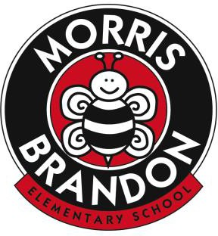

Morris Brandon Elementary School Foundation, Inc.
Request for Funding 2021-2022

To be considered for Foundation funding, an applicant must submit a description and rationale for the proposed project. The Foundation Board’s decision will be based on the information submitted. The Board will not gather additional information to support a proposal. The Foundation Board is made up of parents, teachers and staff who review and consider all funding requests. Decisions are made by a majority of the Foundation Board members present.

For convenience a Funding Proposal Form is included on the website. Applicants may use this form, or one they have created on their own, to submit a proposal. A well-written proposal should include a basis for the request; the anticipated student instructional benefit; actual dollar amount requested with basic back up to verify the expense; and alignment with strategic priorities for the school. Larger requests may also find it helpful to include past years’ requests, if applicable; examples of other schools that have implemented this or a similar idea; and any other information that would assist the Foundation Board in making an informed decision. In addition, the applicant must ensure that all other attempts to obtain funding through APS have been researched and exhausted.

All requests should be emailed to FoundationPresident@morrisbrandon.com, alisonchiock@gmail.com and jbland@atlanta.k12.ga.us. Certain requests in the Teacher Grant category that are less than $1,000 will be considered immediately by a subcommittee of the Board. Items requested in this category include supplies, equipment, instruments, materials for grade level projects, etc. All other requests are subject to the approval of the full Foundation Board and will be considered at the next regularly scheduled meeting, unless there are extraordinary circumstances that require a decision to be made sooner.

Any questions should be directed to:
Alison Chiock, MBESF President, 2021-2022 FoundationPresident@morrisbrandon.com; alisonchiock@gmail.com

Anticipated 2021-2022 Meeting Dates, when proposals will be reviewed:

- August 19, 2021
- September 15, 2021
- October 21, 2021
- November 18, 2021
- December 16, 2021
- January 20, 2022
- February 16, 2022
- March 17, 2022
- April 21, 2022
- May 19, 2022

